# Task 2: Create an AWS CloudFormation with auto delete feature

- Create S3 Bucket and integrate lambda function to it,

- Whenever a file is uploaded to S3 Bucket Lambda function will display file contents.

- While Deleting CF Stack, it should delete all underlying resources (also delete S3 Bucket objects)

## Pre Checks

### CF Stack

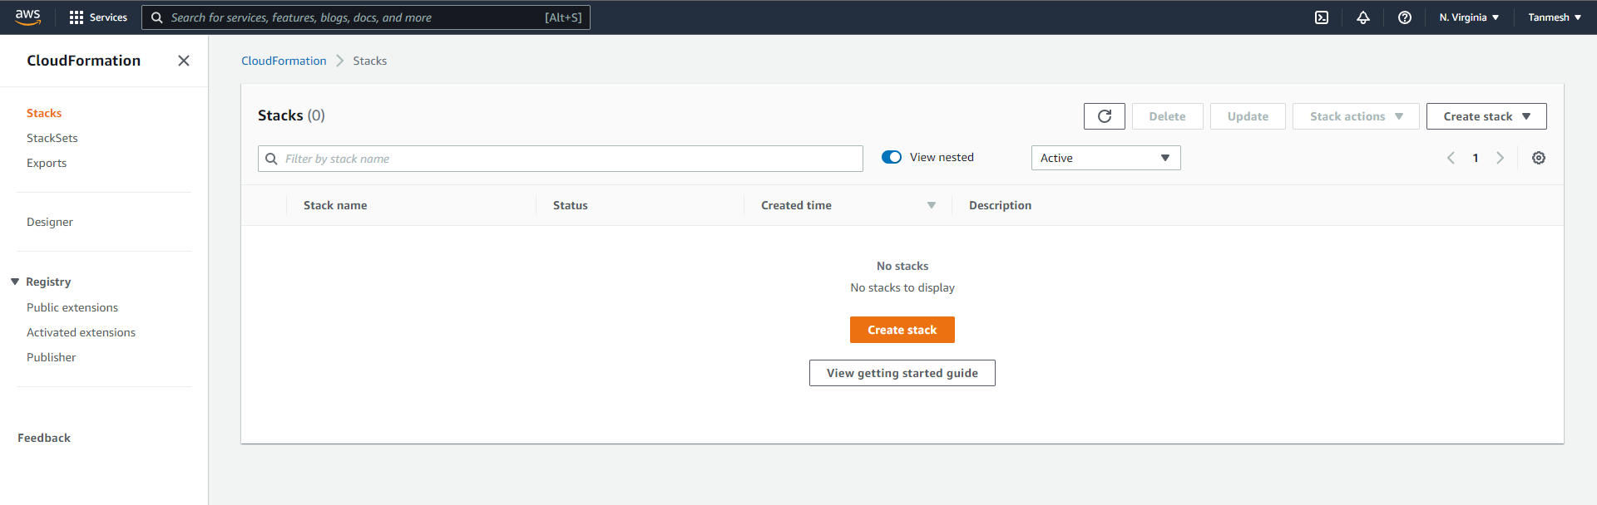

### S3 Bucket

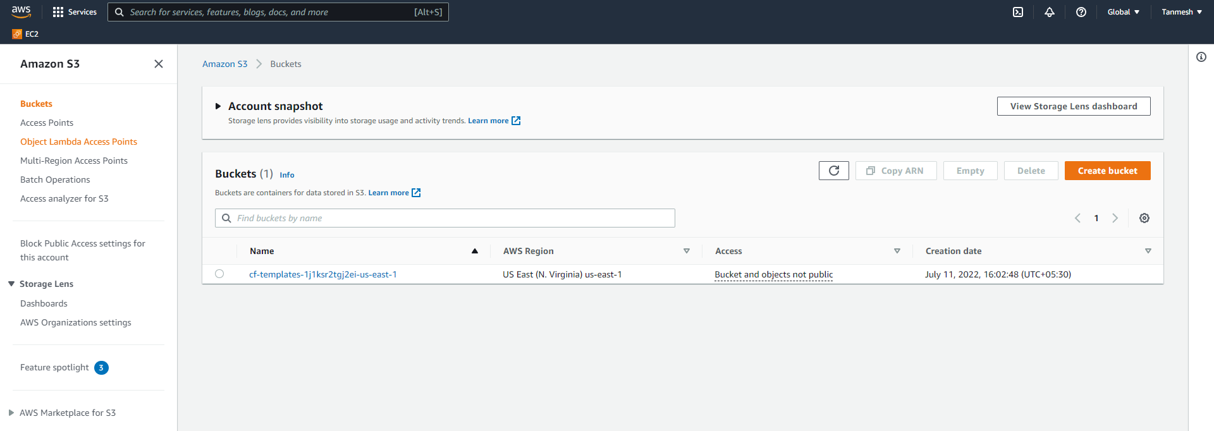

### Lambda Function

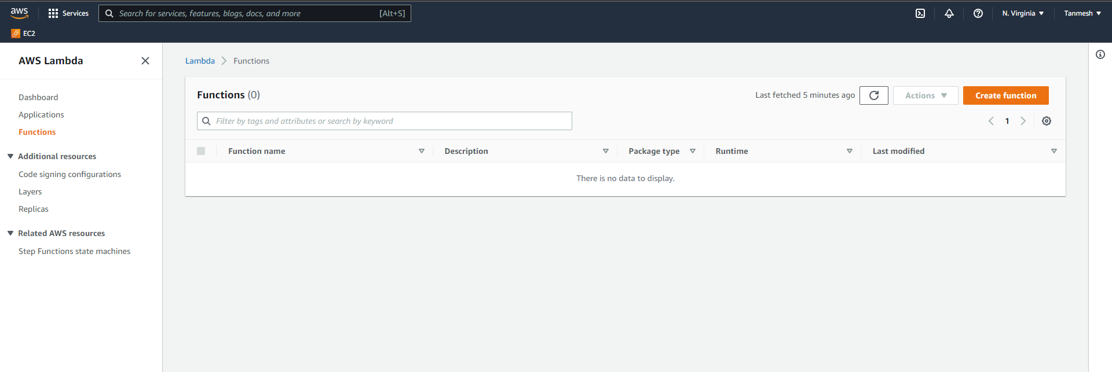

### IAM Role

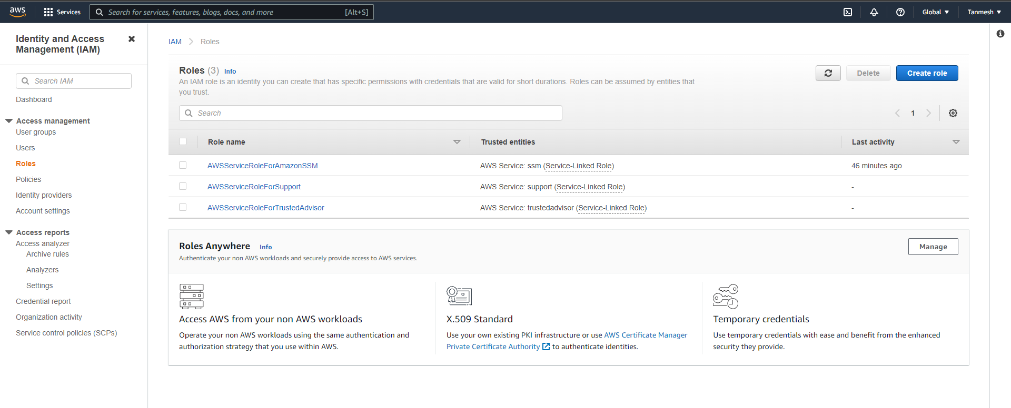

## Create CF Stack

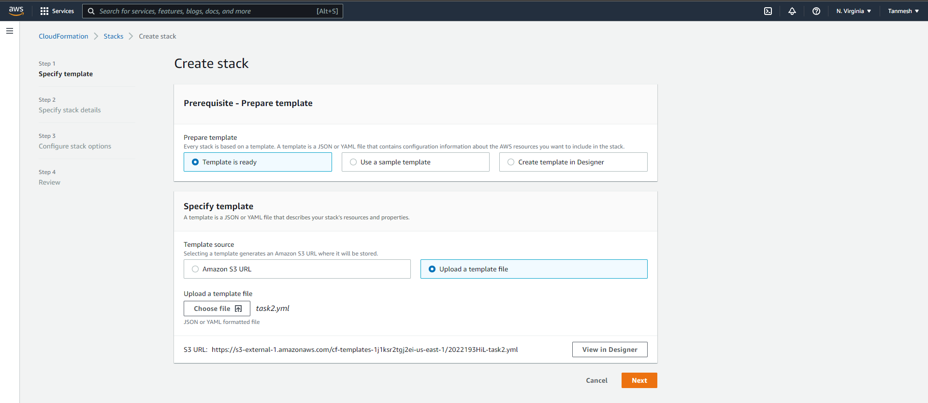

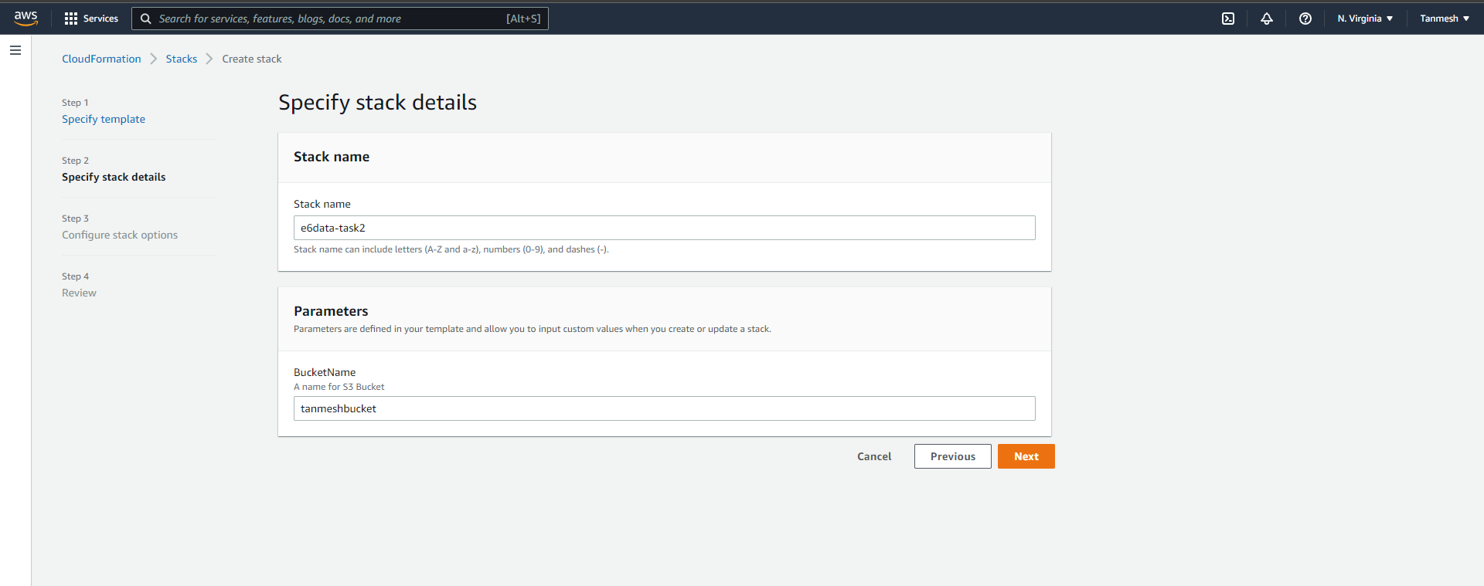

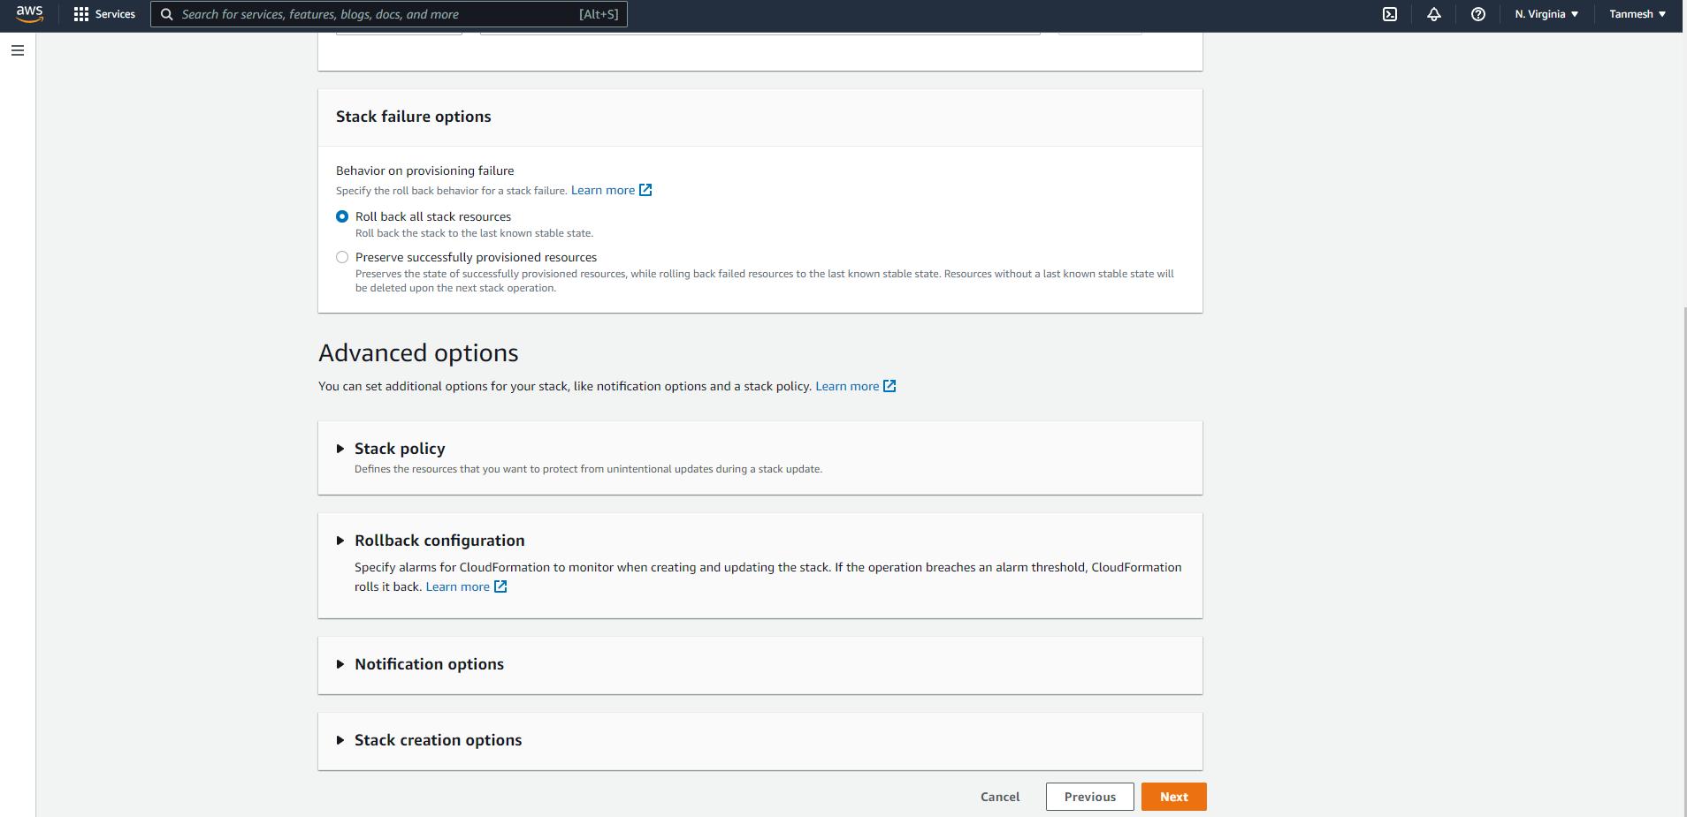

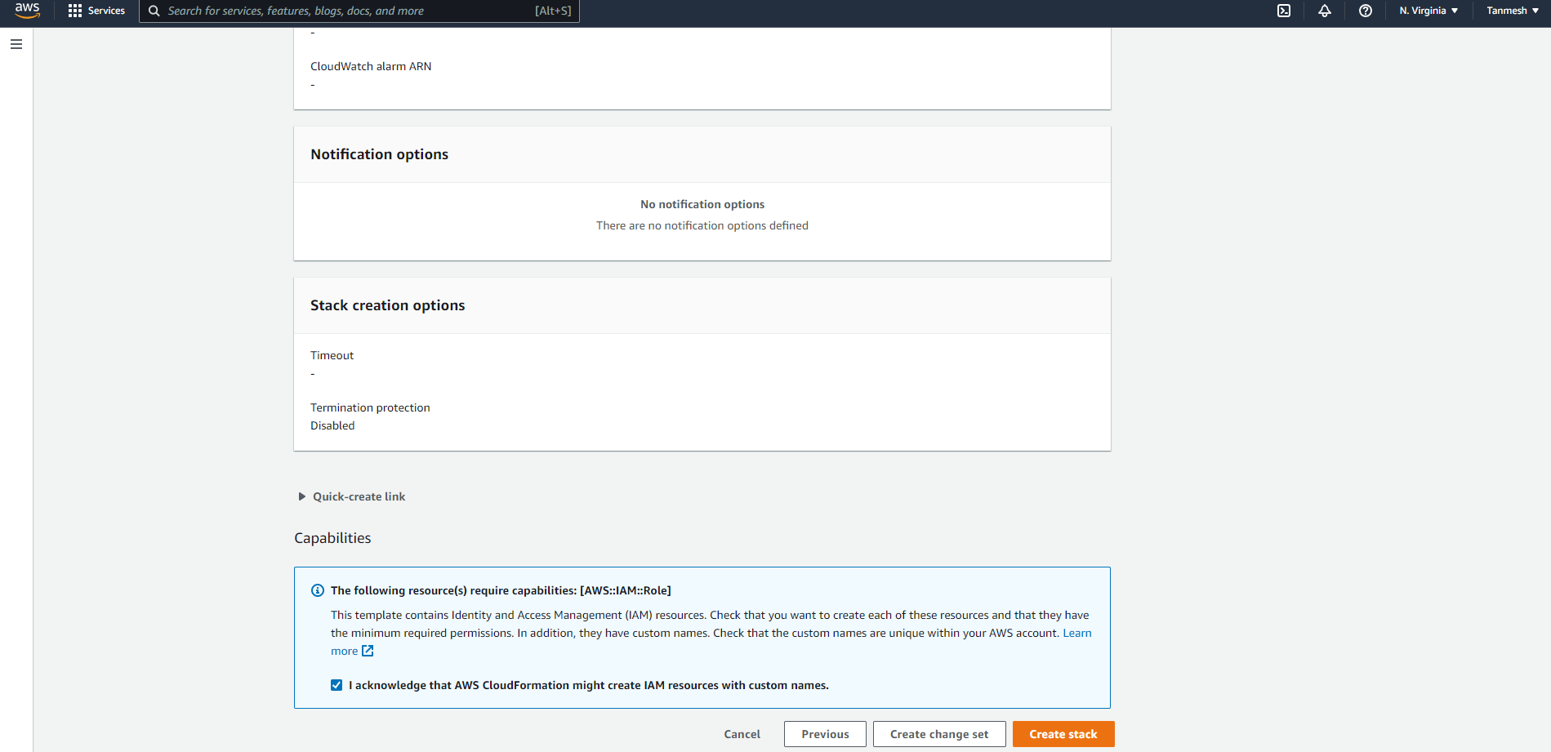

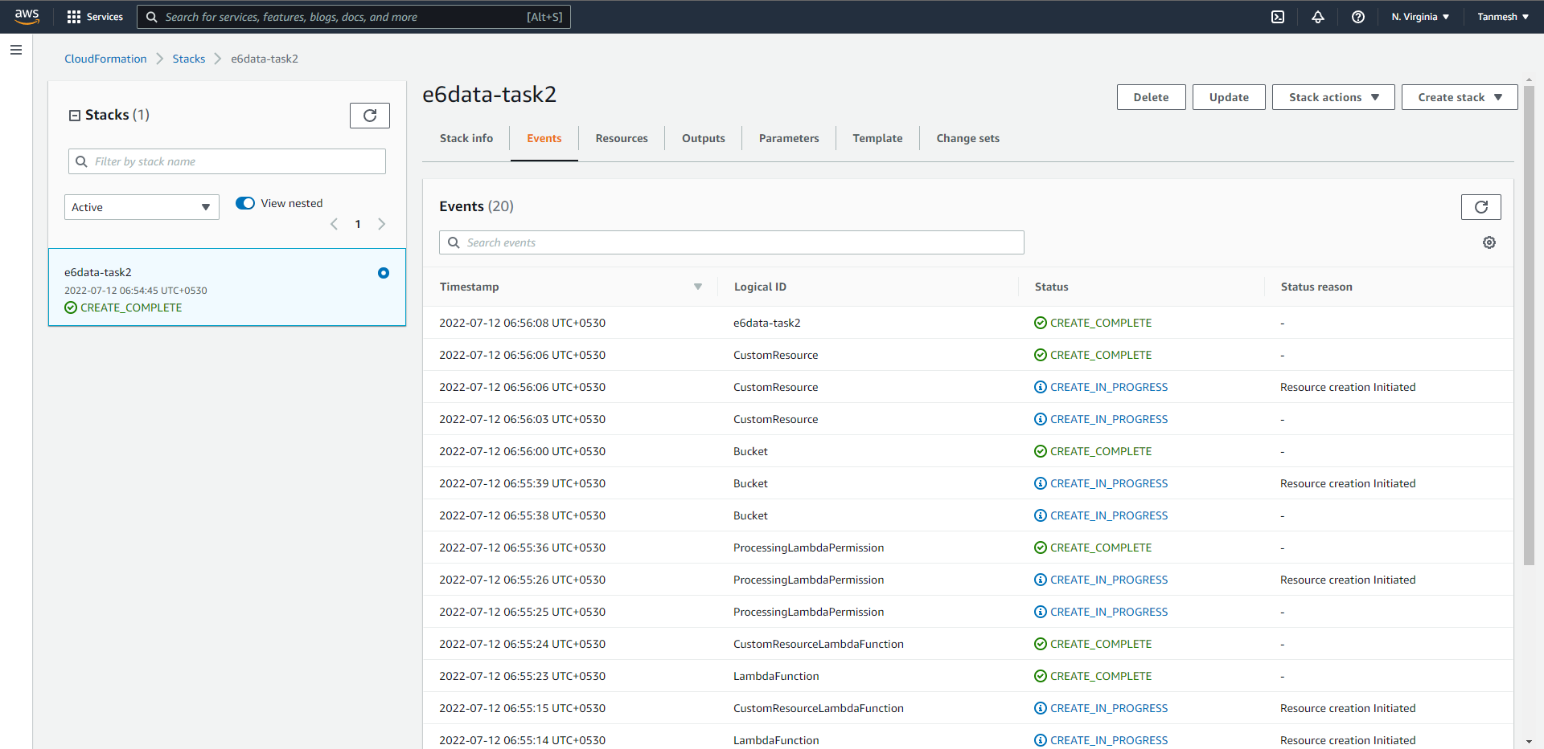

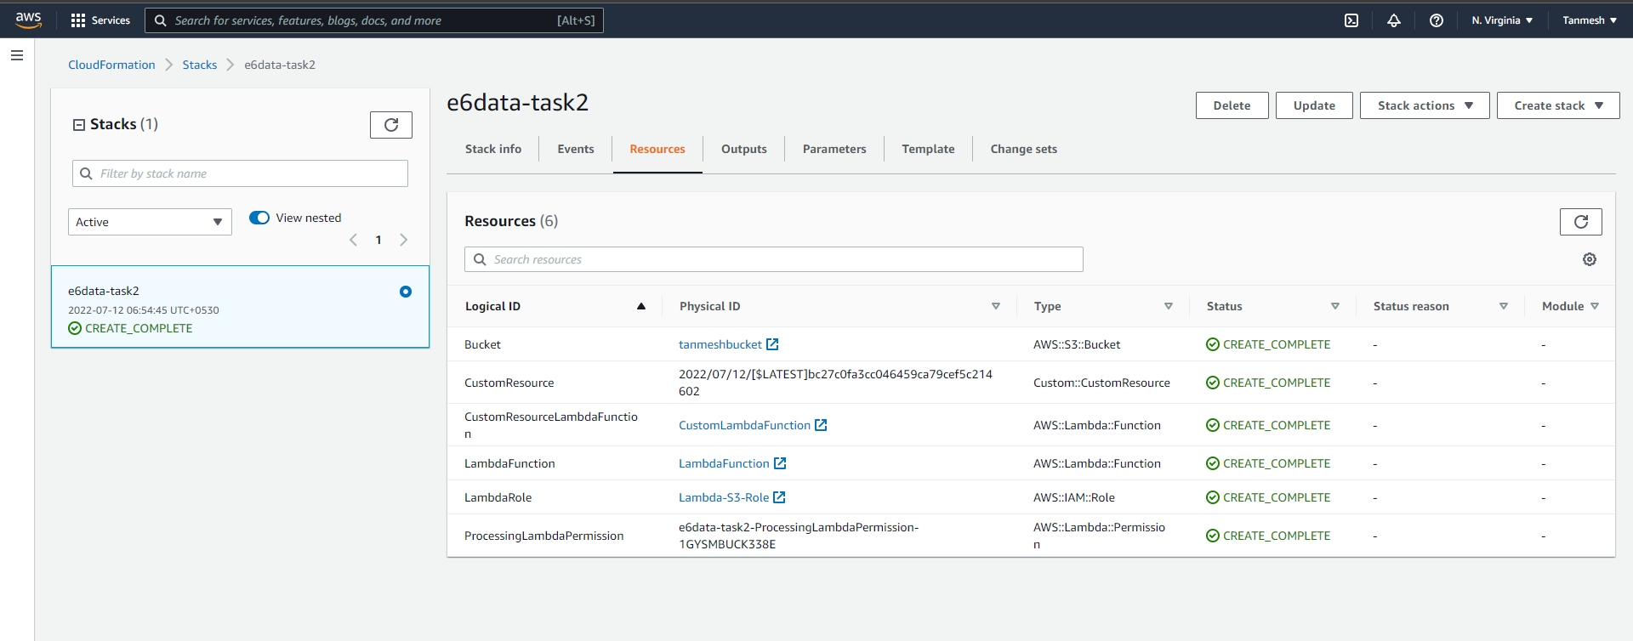

## Post Checks

### CF Stack

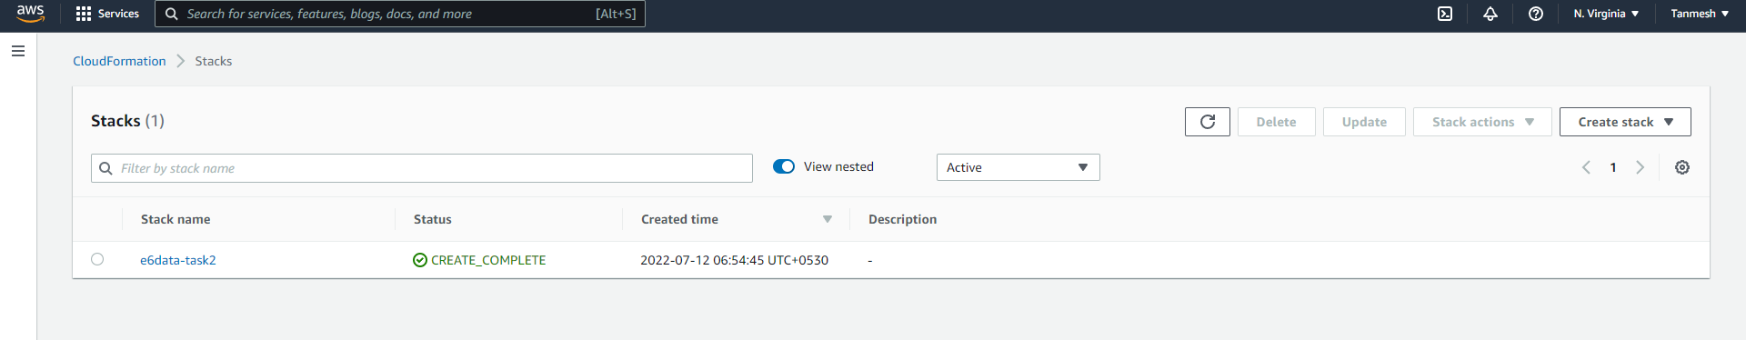

### S3 Bucket

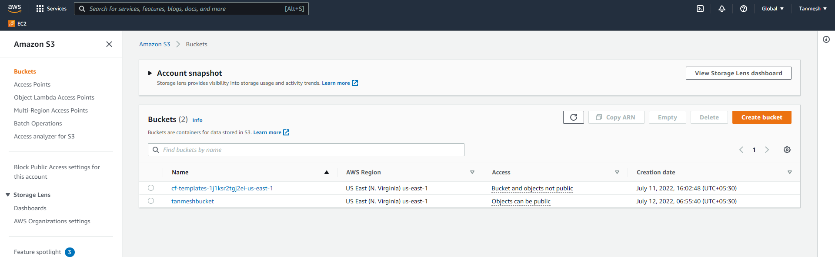

### Lambda Function

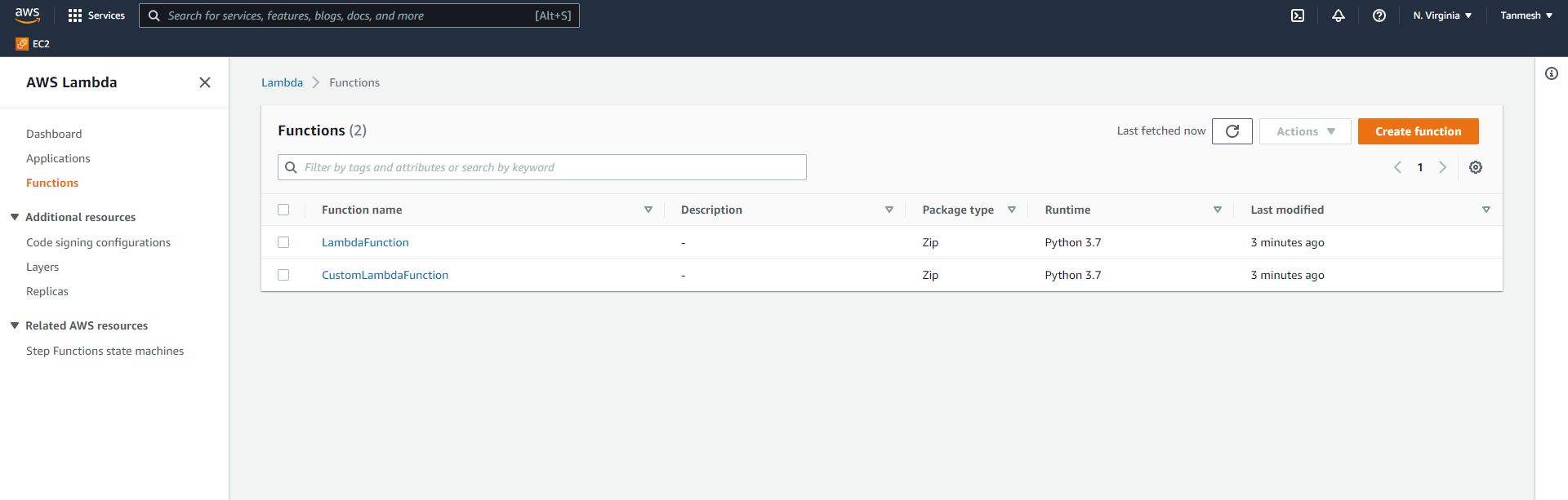

### IAM Role

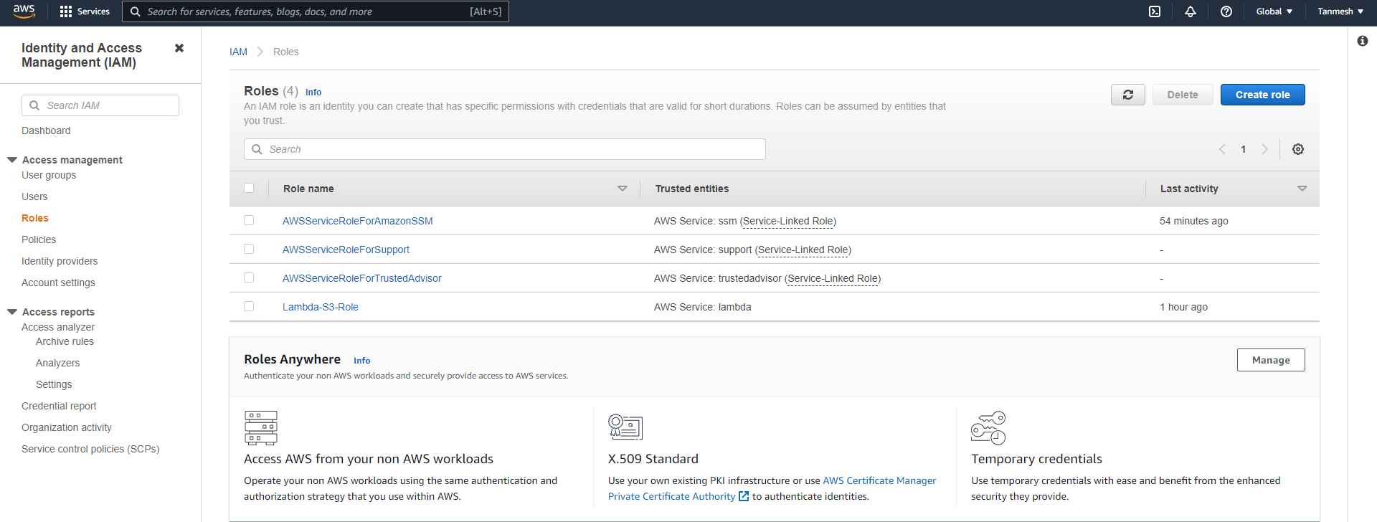

## Upload file to S3 Bucket and check logs

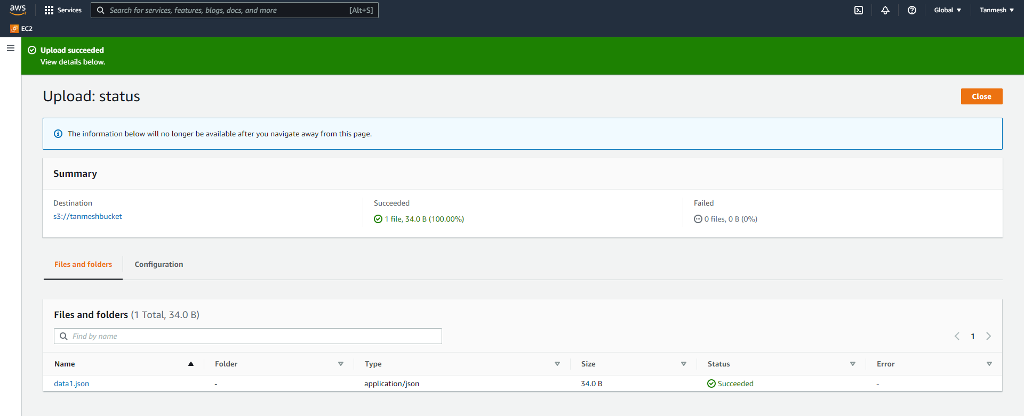

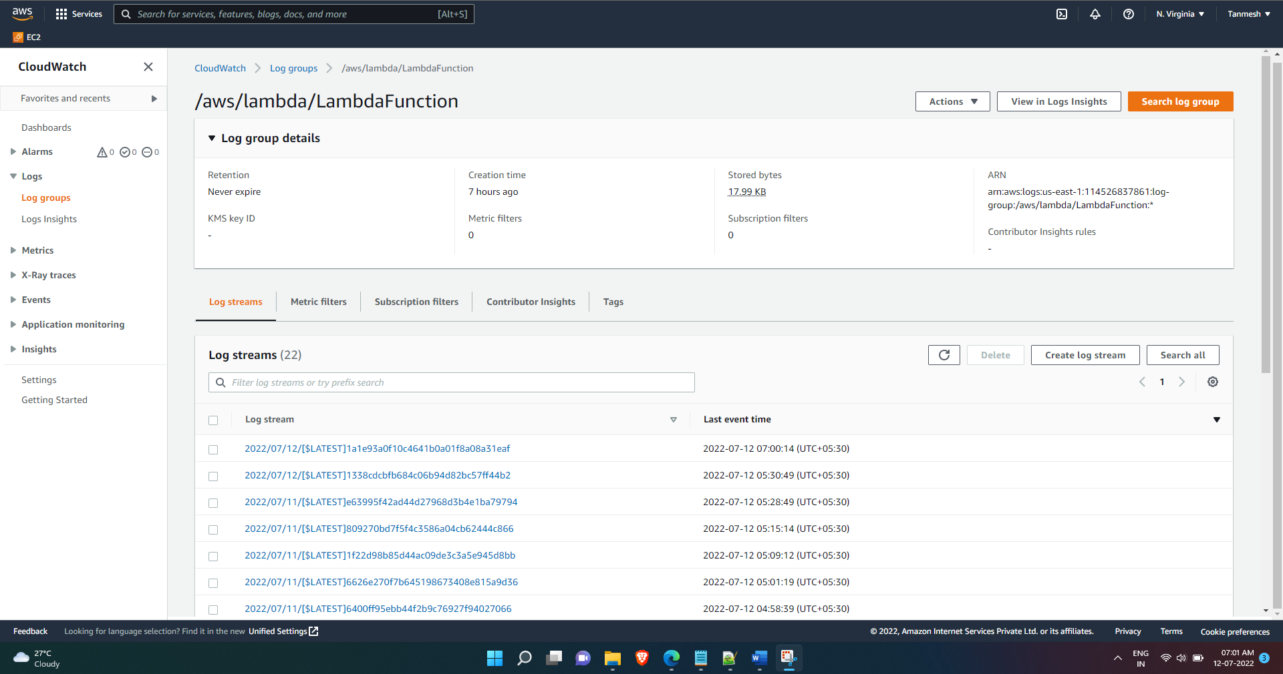

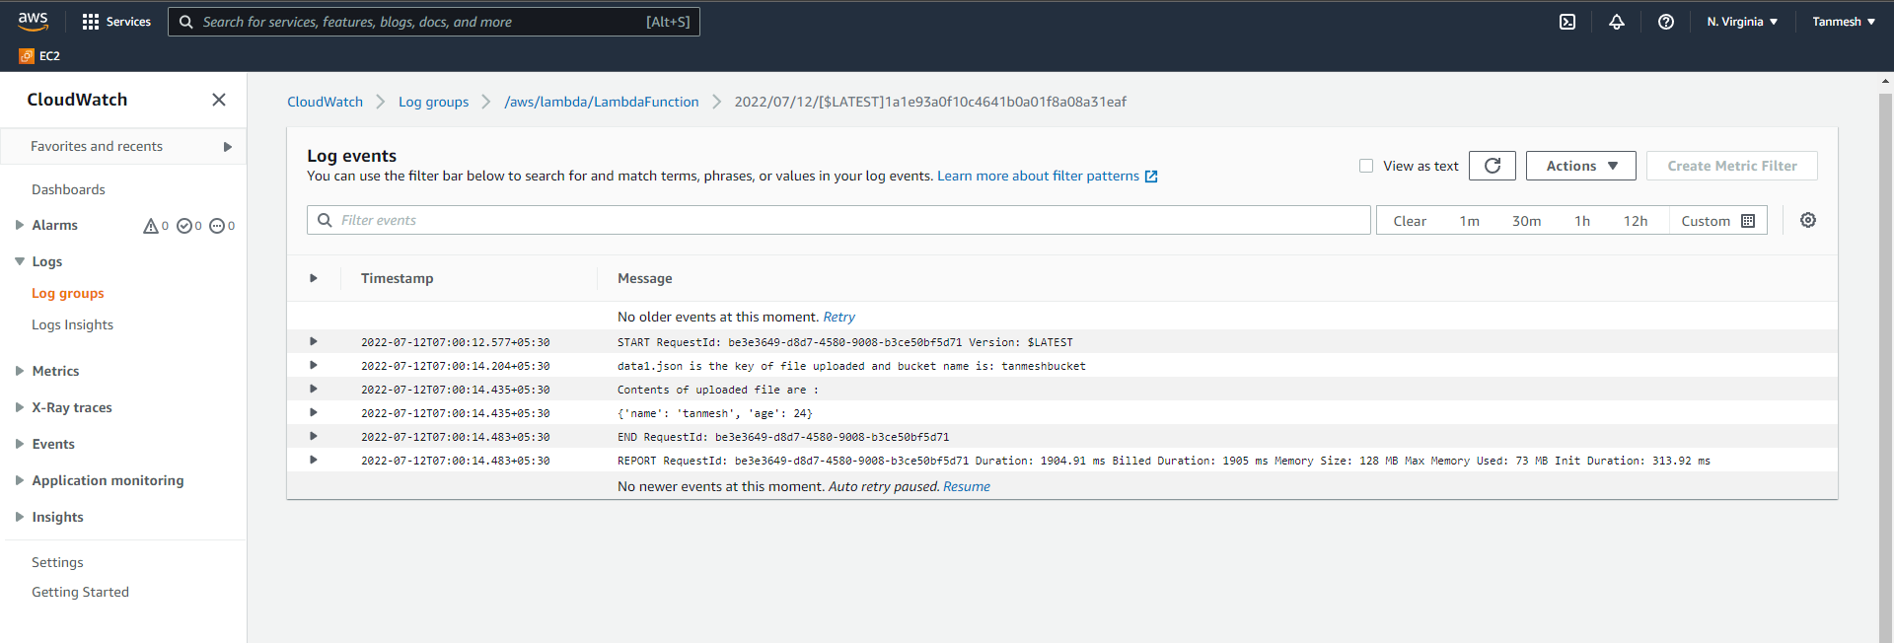

Now Delete CF Stack (S3 Bucket has files present in it)

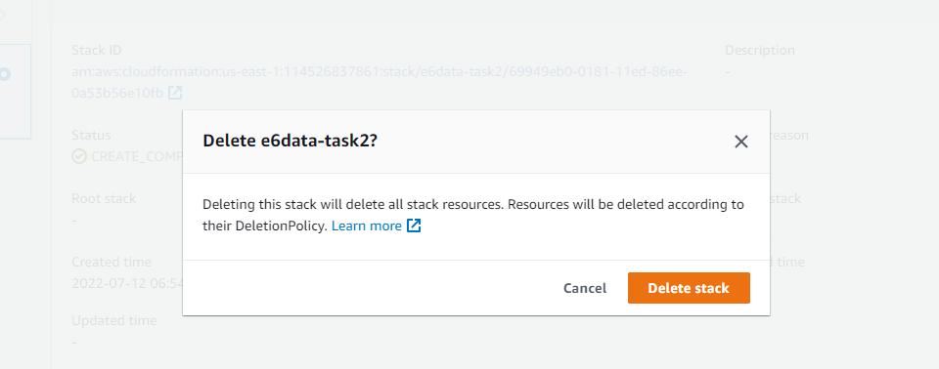

All resources are deleted even though, S3 Bucket had data files

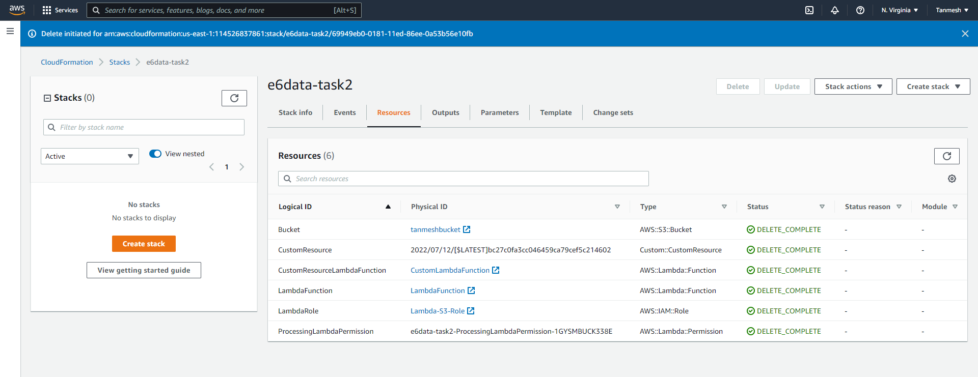

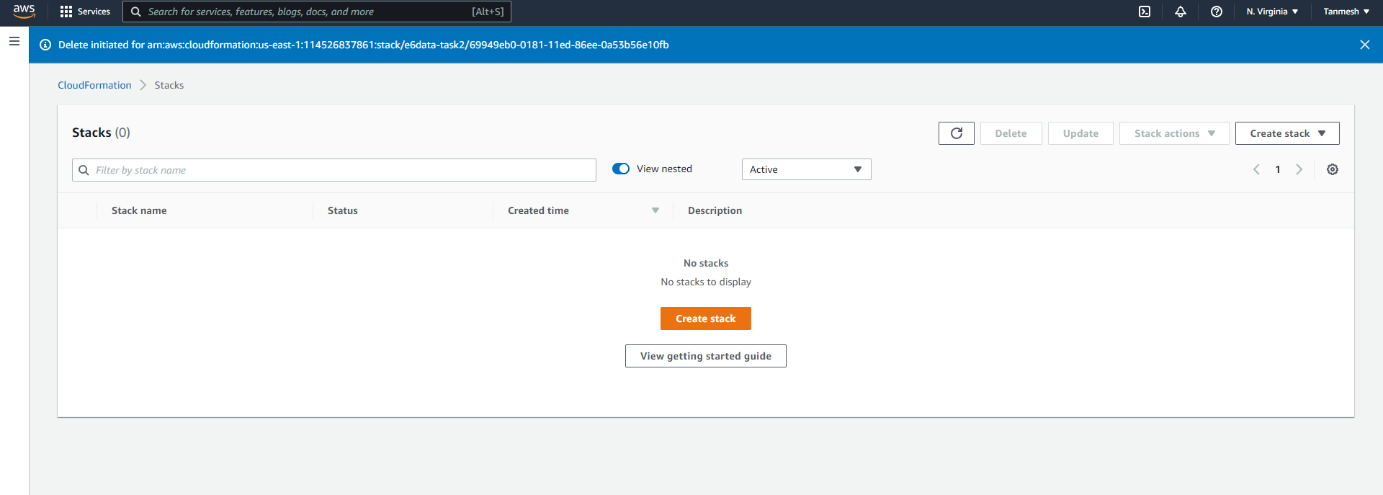

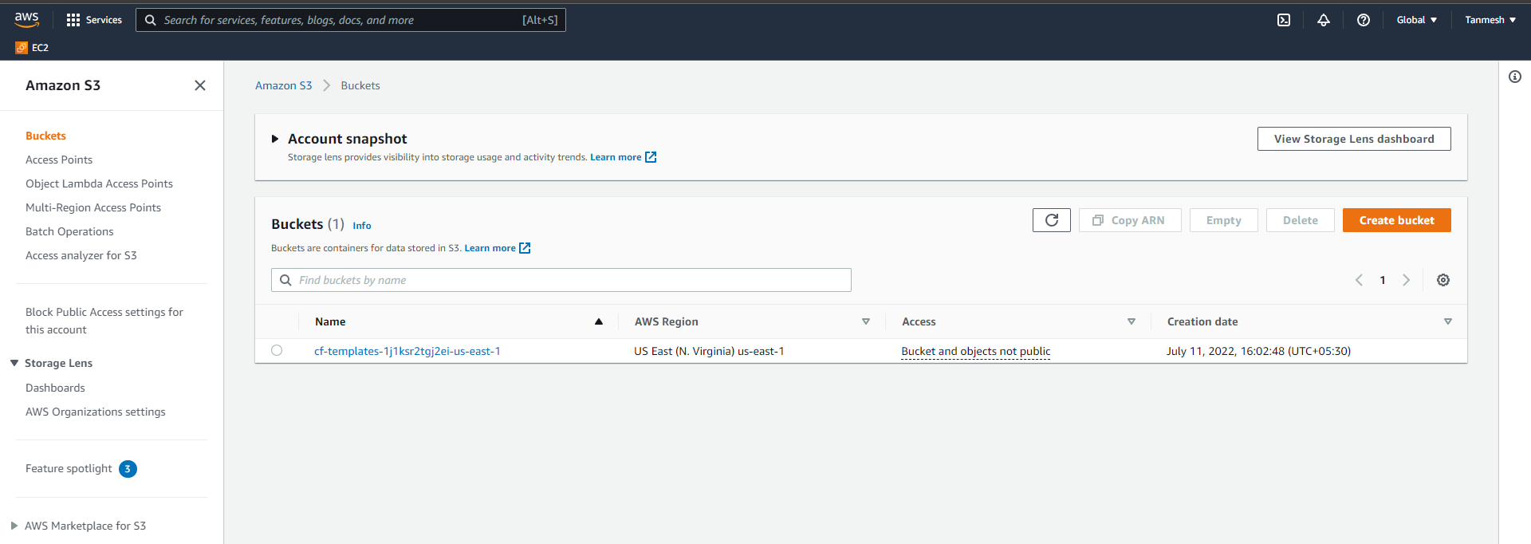

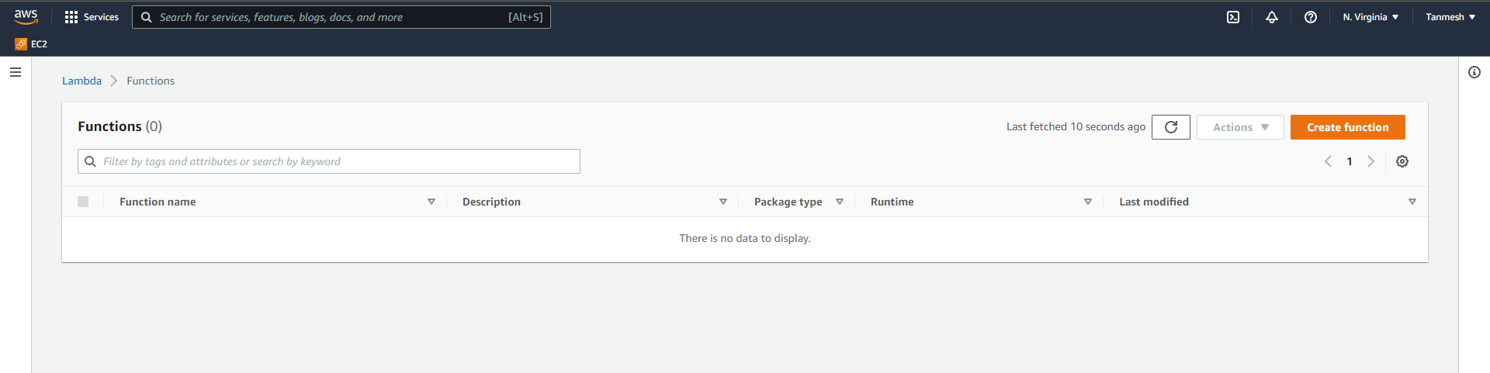

Log events

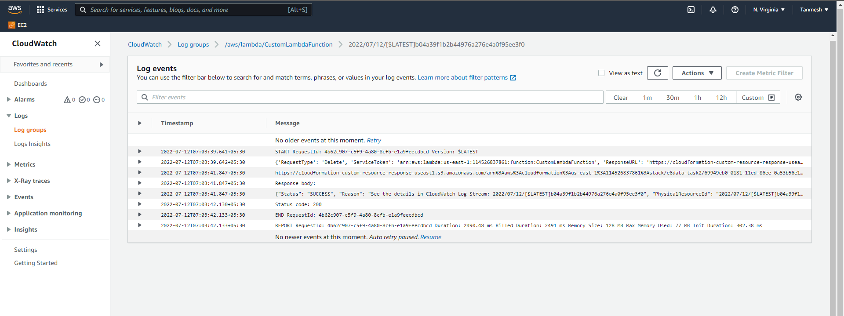

Github repo link

<https://github.com/tanmeshbhokare/cloudformation.git>